FOR IMMEDIATE RELEASE

Date: June 26, 2015
Subject: Massive New Orleans Land Deal
Contact: Sidney D. Torres, IV
IV Capital, LLC
Ph: 504-533-8781
Email: storres@sdtivcapital.com
Encl: Torres Photo; Bayou St. John Site Plan/Aerial

______________________________________________________________________

Entrepreneur Sidney Torres IV Buys Largest Remaining
Mid-City Tract of Land from Railroad

“New Approach to Development” Invites Ideas that Complement Bayou St. John Neighborhood

New Orleans, LA - IV Capital, the venture capital firm founded by New Orleans entrepreneur Sidney Torres, IV, funded the sale Friday of a nine-acre plot of land along Bayou St. John in Mid-City. With approximately 380,000 square feet adjacent to the Lafitte Greenway, the tract is one of the most expansive continuous pieces of land slated for development in New Orleans. The sale completed the largest transfer of mid-city land in decades and is a sign of the pace of development in New Orleans as the city approaches the 10-year anniversary of Hurricane Katrina.

Torres and Partners plans to develop the property into a high-end mixed-use residential and commercial community well situated to serve the area’s burgeoning medical district. “When I first saw this property I was amazed by its beauty and centralized convenience,” Torres said. “It’s going to be a wonderful place to live and visit.”

Preliminary plans call for homes and amenities to be developed in collaboration with experienced builders to fit seamlessly within the fabric of the New Orleans cityscape and specifically the Bayou St. John neighborhood. Torres continued, “I’m excited to have such a great canvas on which to paint our shared vision.”

Bayou St. John will be the flagship residential connector between downtown New Orleans and the French Quarter to City Park. It was patterned to be similar in quality of life to Florida’s Alys Beach and is entirely in keeping with New Orleans’ historic architecture. Torres envisions a community with apartments and houses, kayaks and paddleboards along the bayou, fire pits on the bank, children’s playgrounds as well as bike paths, a gymnasium, café and boutique hotel. “We have already been contacted by an experienced builder about developing two 80,000 square-foot parcels into apartments and we encourage people to bring their best ideas to the table,” Torres reiterates. “This is an entirely new approach to development. If you have a great idea, Bayou St. John is the opportunity you’ve been waiting for.”

One plan under consideration is for substantial portions of the community to be closed to vehicular traffic with walkways for pedestrians and bicycles only. “We can build houses so that the garage is in the rear and no cars are allowed on the bayou side,” Torres explains. “Everything is preliminary, but the limits of possibility are what people can imagine and what is good for the community. It’s an exciting process.”

Torres, via IV Capital, is the managing partner of a trio of accomplished investors including Joseph Jaeger and Hicham Khodr. Jaeger, owner of MCC Group, has a deep resume in developing New Orleans real estate and owns a number of hotels. Khodr is the man behind such well-known Big Easy venues as Camellia and has partnered with Emeril Lagasse to create the popular French Quarter restaurant Nola. Commenting on the partnership, Torres said, “This was an opportunity to create a powerful coalition. Their expertise in New Orleans development will add great depth and confidence to the project.”

The Bayou St. John development marks a renewed emphasis for Torres on the New Orleans real estate front where he began his career 20 years ago. In the past several years, he has developed and sold upscale resorts in the U.S. and Caribbean, amassing a large real estate portfolio. He is now poised to bring his signature intensity to creating high-end living and working communities in New Orleans and throughout Louisiana.

“I like to spend a lot of time walking around and immersing myself in the atmosphere of a piece of land before I develop it,” Torres explained. “I get more exhilarated every time I visit the Bayou St. John site. Its design and creation is an opportunity to do something genuinely unique to benefit our city. Since its creation five years ago, IV Capital’s mission has always been about helping people accomplish their dreams. This is one of mine.”

-END –
(647 words)

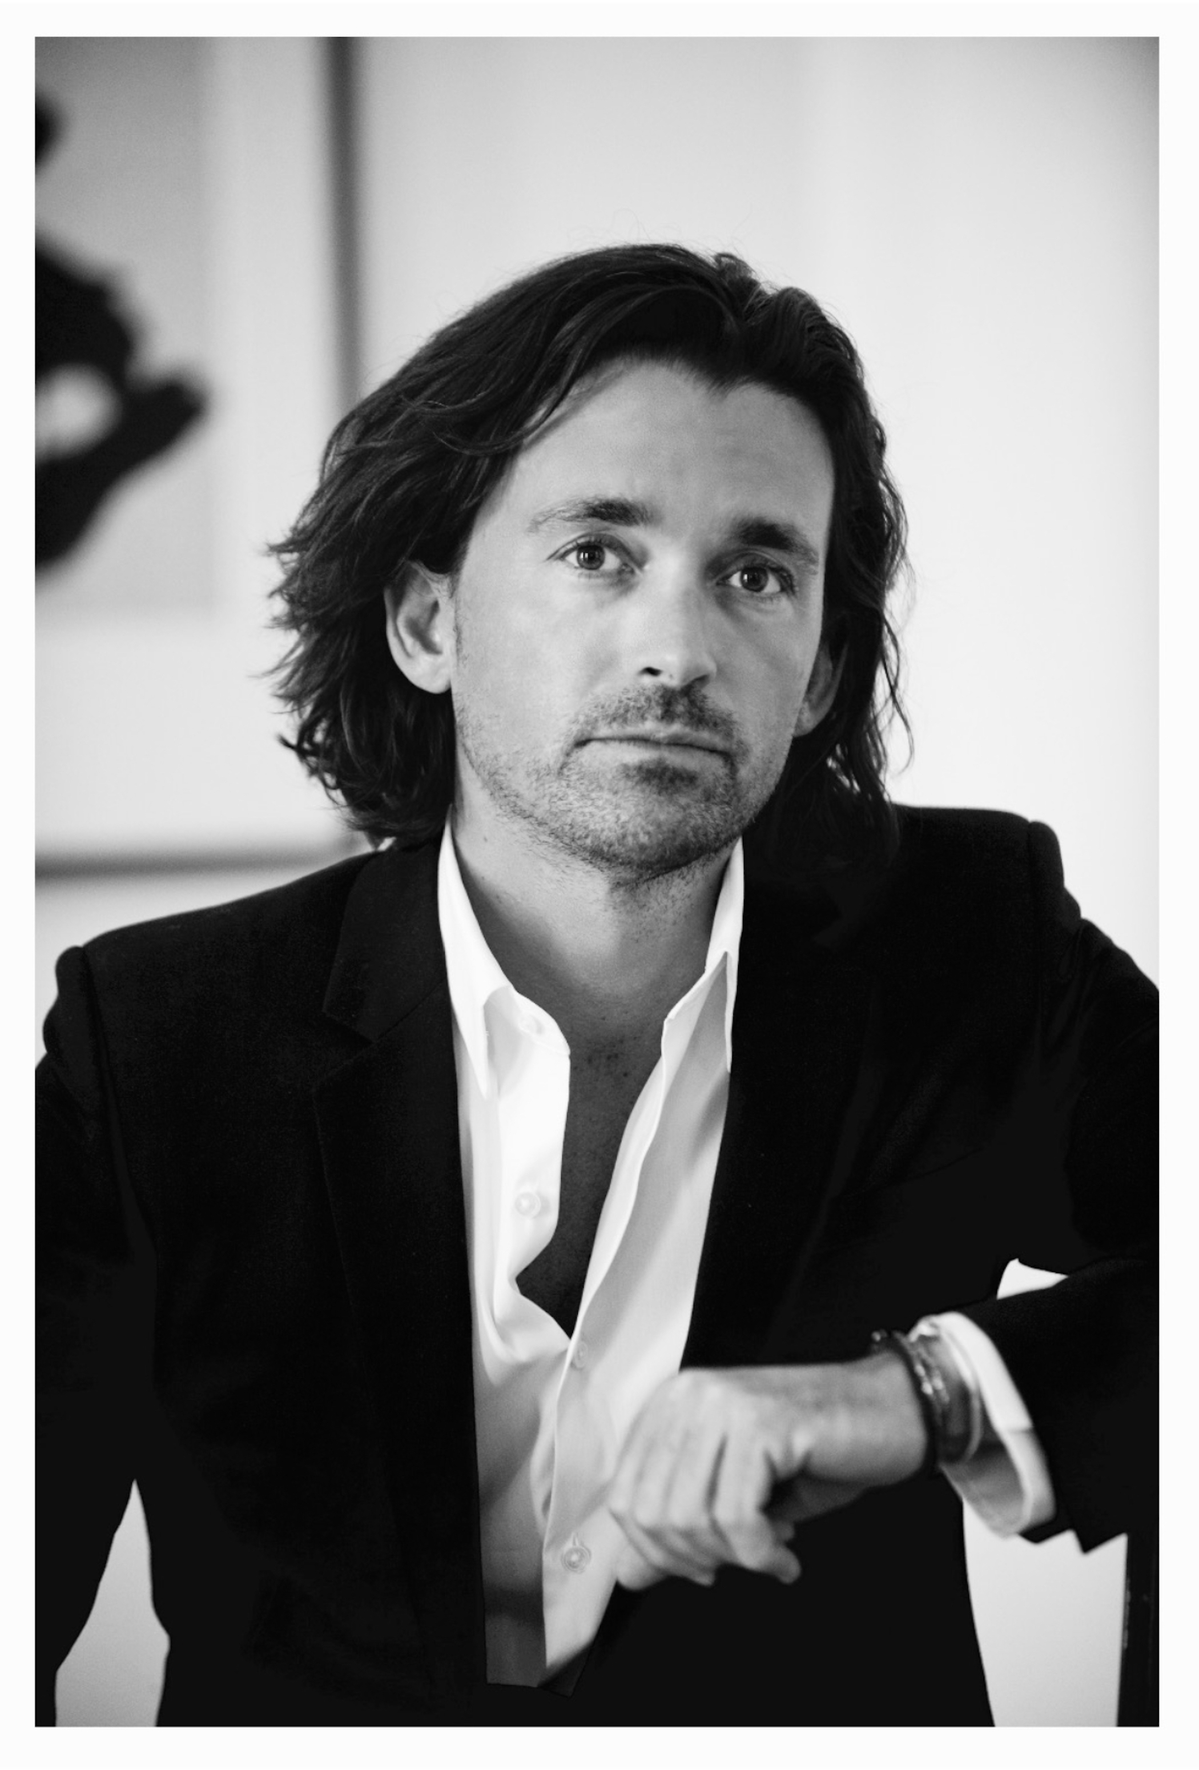

Sidney D. Torres, IV
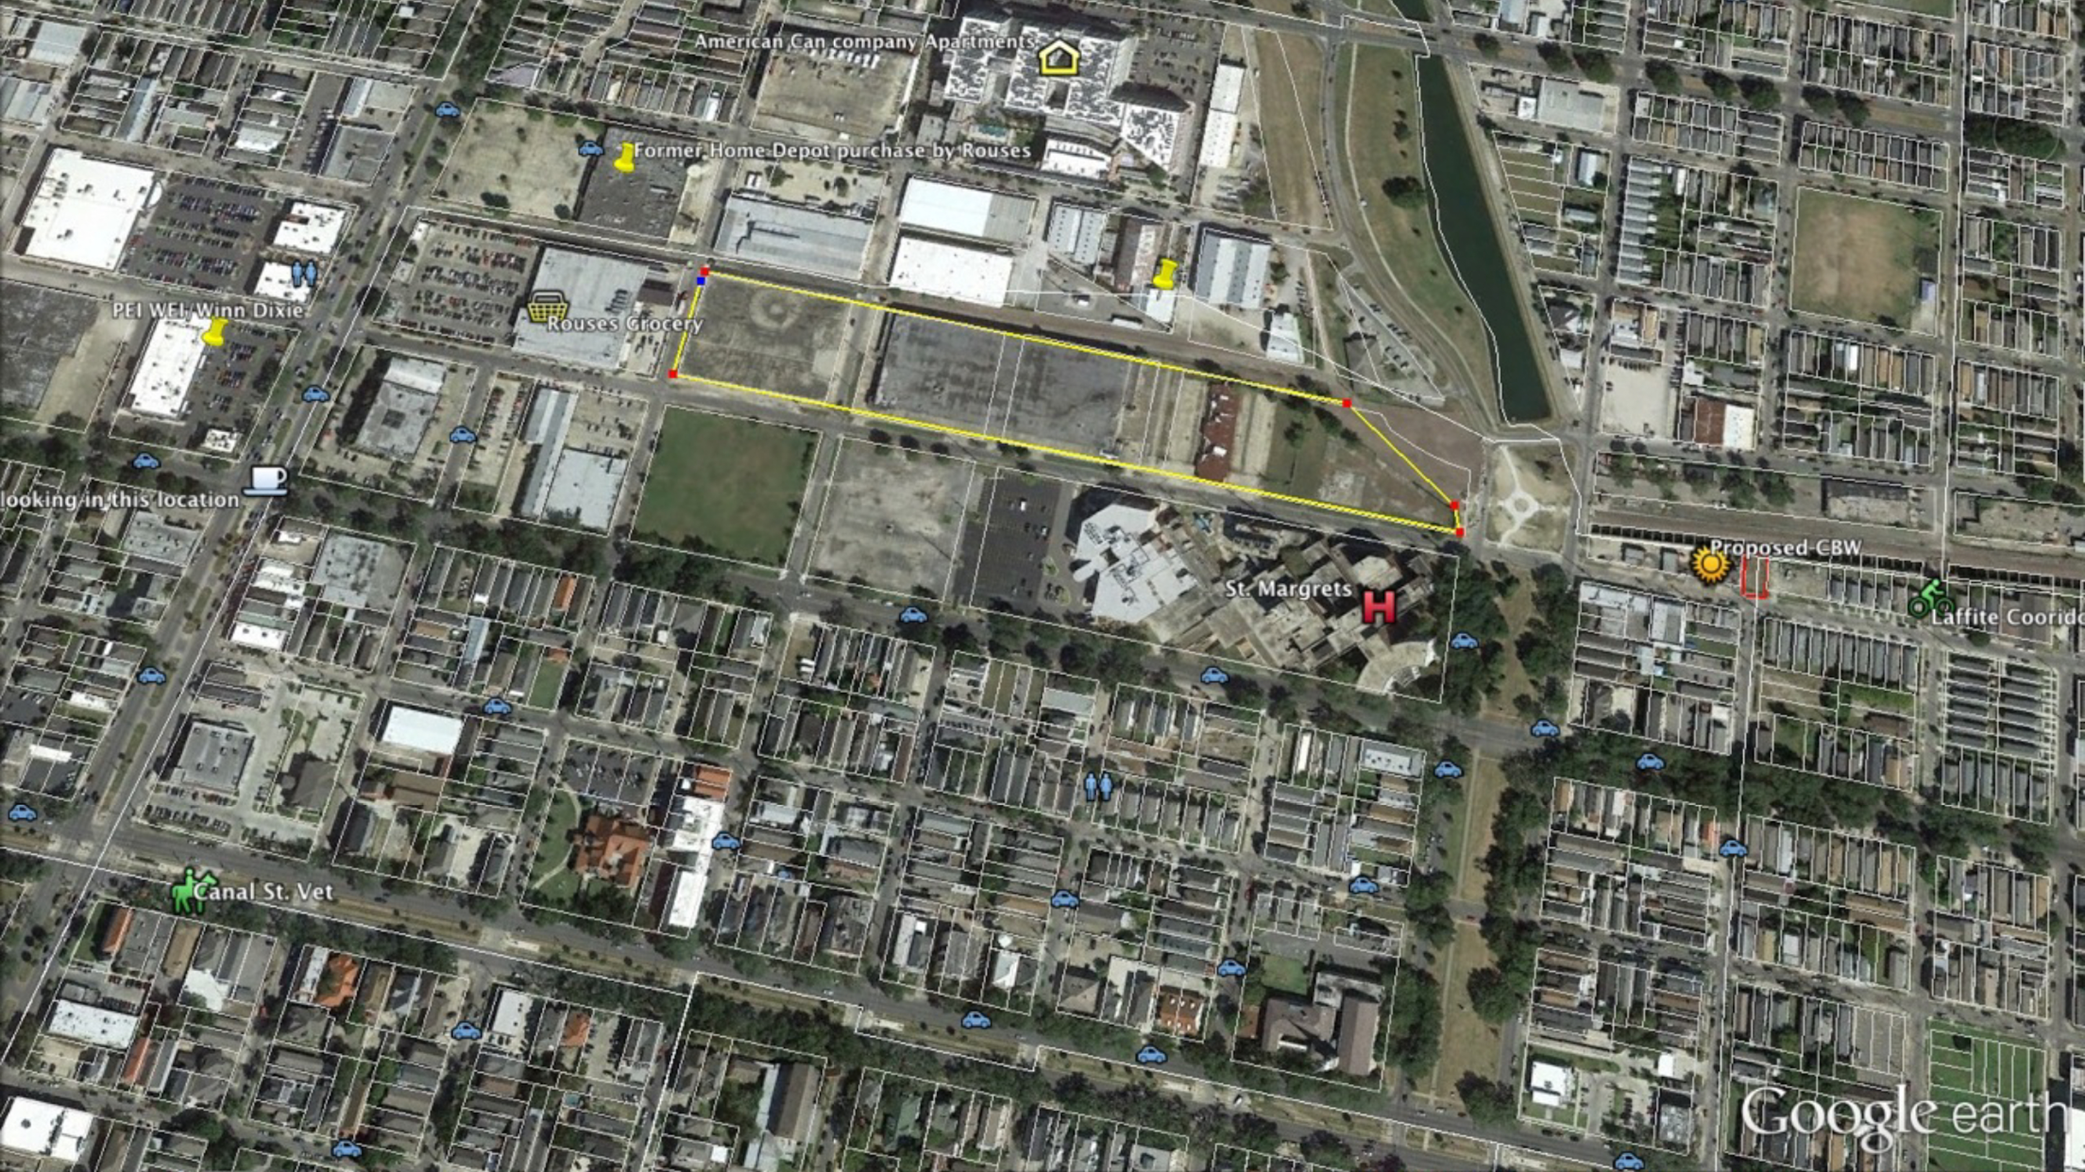

Bayou St. John Aerial

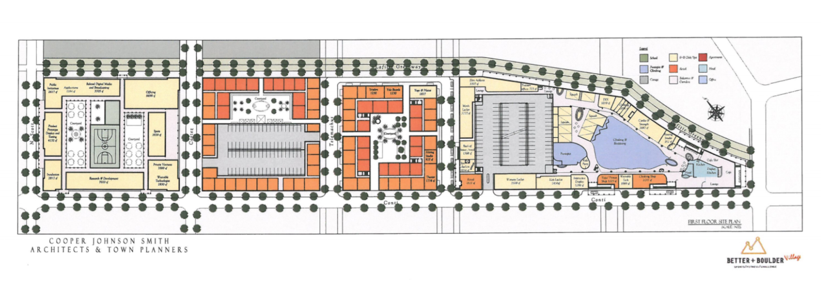

Bayou St. John Site Plan

